Lab 3 Report

A) Requirements Document

1. Overview

1.1. Objectives: Why are we doing this project? What is the purpose?

The objectives of this project are to design, build and test an alarm clock. Educationally, students are learning how to design and test modular software and how to perform switch/keypad input in the background.

1.2. Process: How will the project be developed?

The project will be developed using the TM4C123 board. There will be seven switches. The system will be built on a solderless breadboard and run on the usual USB power. The system may use the on board switches and/or the on board sound. Alternatively, the system may include an external keypad and/or speaker. There will be at least four hardware/software modules: switch input, time management, LCD graphics, and sound output. The process will be to design and test each module independently from the other modules. After each module is tested, the system will be built and tested.

1.3. Roles and Responsibilities: Who will do what? Who are the clients?

EE445L students are the engineers and the TA is the client. Students are expected to modify this document to clarify exactly what they plan to build. Students are allowed to divide responsibilities of the project however they wish, but, at the time of demonstration, both students are expected to understand all aspects of the design.

1.4. Interactions with Existing Systems: How will it fit in?

The system will use the TM4C123 board, a ST7735 color LCD, a solderless breadboard, and be powered using the USB cable.

1.5. Terminology: Define terms used in the document.

Power budget: dividing the energy stored in a battery by the average current required to run the system

device driver: a collection of software routines that perform I/O functions

critical section: Locations within a software module, where if an interrupt were called, would cause problems within the program like data loss or program crashing

latency: response time of the computer to external events

time jitter: deviation from the periodic signal, measure by largest recorded time subtracted by the smallest recorded time.

modular programming: software design technique that focuses on separating functions into separate self-sustaining modules allowing reuse if necessary.

1.6. Security: How will intellectual property be managed?

The system may include software from Tivaware and from the book. No software written for this project may be transmitted, viewed, or communicated with any other EE445L student past, present, or future (other than the lab partner of course). It is the responsibility of the team to keep its EE445L lab solutions secure.

2. Function Description

2.1. Functionality: What will the system do precisely?

The clock must be able to perform five functions. 1) It will display hours and minutes and seconds in both graphical and numeric forms on the LCD. The graphical output will include the 12 numbers around a circle, the hour hand, and the minute hand and the seconds hand. The numerical output will be easy to read. 2) It will allow the operator to set the current time using switches. 3) It will allow the operator to set the alarm time including enabling/disabling alarms. 4) It will make a sound at the alarm time. 5) It will allow the operator to stop the sound. An LED heartbeat will show when the system is running.

2.2. Scope: List the phases and what will be delivered in each phase.

Phase 1 is the preparation; phase 2 is the demonstration; and phase 3 is the lab report. Details can be found in the lab manual.

2.3. Prototypes: How will intermediate progress be demonstrated?

A prototype system running on the TM4C123 board, ST7735 color LCD, and solderless breadboard will be demonstrated. Progress will be judged by the preparation, demonstration and lab report.

2.4. Performance: Define the measures and describe how they will be determined.

The system will be judged by three qualitative measures. First, the software modules must be easy to understand and well-organized. Second, the clock display should be beautiful and effective in telling time. Third, the operation of setting the time and alarm should be simple and intuitive. The system should not have critical sections. All shared global variables must be identified with documentation that a critical section does not exist. Backward jumps in the ISR should be avoided if possible. The interrupt service routine used to maintain time must complete in as short a time as possible. This means all LCD I/O occurs in the main program. The average current on the +5V power will be measured with and without the alarm sounding.

2.5. Usability: Describe the interfaces. Be quantitative if possible.

There will be SEVEN switch inputs. In the main menu, the switches can be used to activate 1) set time; 2) set alarm; 3) turn on/off alarm; and 4) display mode switching between the two options 5) separate buttons to increase the seconds, minutes, or hours on the alarm or actual time setting, in both display modes. The display mode switch toggles between graphical and numeric displays. The switches will be debounced, so only one action occurs when the operator touches a switch once.

The LCD display shows the time using graphical display typical of a standard on the wall clock. The 12 numbers, the minute hand, and the hour hand are large and easy to see. The clock can also display the time in numeric mode using numbers.

The alarm sound can be a simple square wave. The sound amplitude will be just loud enough for the TA to hear when within 3 feet.

2.6. Safety: Explain any safety requirements and how they will be measured.

The alarm sound will be VERY quiet in order to respect other people in the room during testing. Connecting or disconnecting wires on the protoboard while power is applied may damage the board.

3. Deliverables

3.1. Reports: How will the system be described?

A lab report described below is due by the due date listed in the syllabus. This report includes the final requirements document.

3.2. Audits: How will the clients evaluate progress?

The preparation is due at the beginning of the lab period on the date listed in the syllabus.

3.3. Outcomes: What are the deliverables? How do we know when it is done?

There are three deliverables: preparation, demonstration, and report.

B) Hardware Design

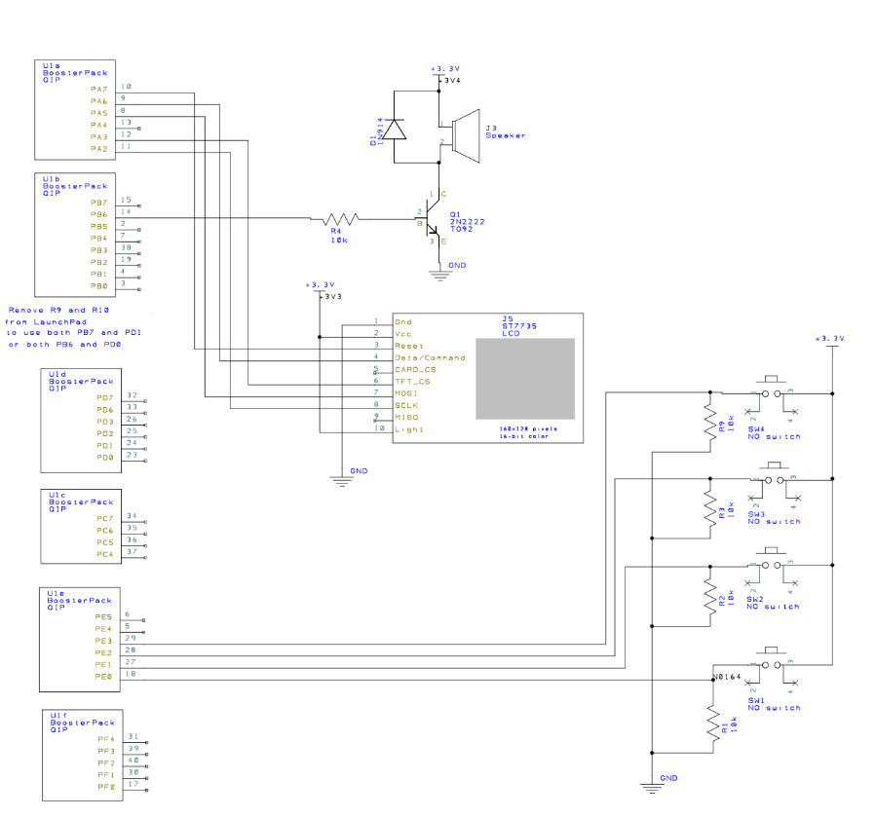

C) Software Design

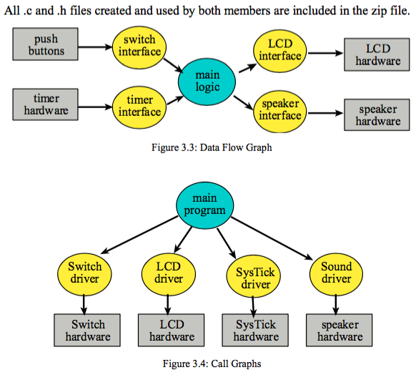

D)Measurements Data

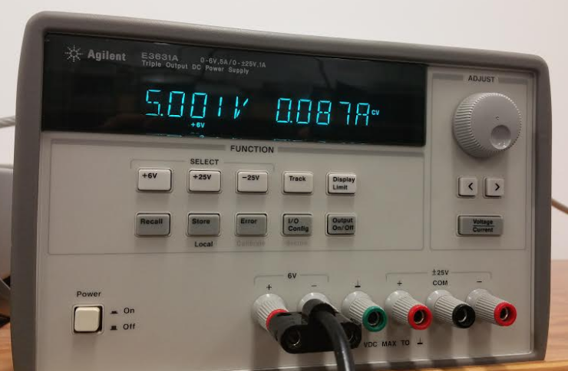

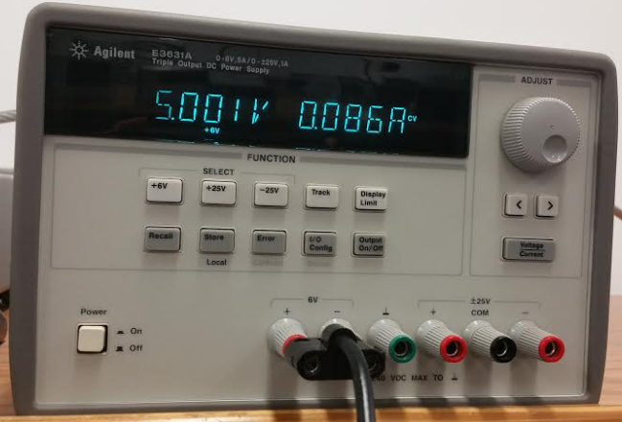

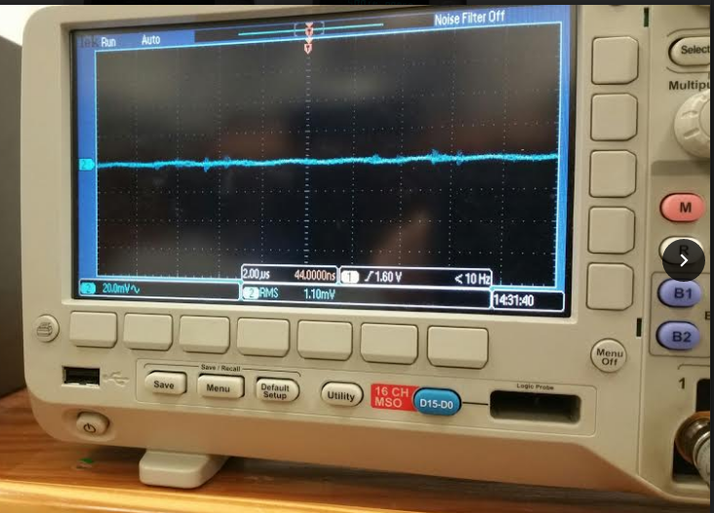

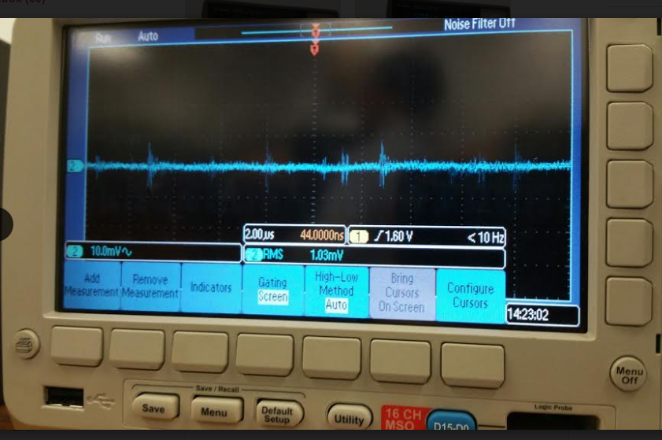

E) Analysis and discussion

1) give two ways to remove a critical section

One of the two ways would be to remove global variables not allowing the ISR to change any of the values that another function or handler would be dependent on. The second way would be to completely disable interrupts during the duration of writing or reading from the global variables in common.

2) How long does it take to update the LCD with a new time

It takes 0.015 seconds to update the time on the display.

3) What would be the disadvantage of updating the LCD in the background ISR?

Updating the LDC in the background ISR would be disadvantageous because it causes the system to no longer be real-time and increase the latency of the program running.

4) Did you redraw the entire clock for each output? If so, how could you have redesigned the LCD update to run much faster and create a lot less flicker

Yes, we redrew the entire clock for each output. Initially we had it draw at every cycle of the while loop in main but in order to decrease the flickering we create a value that would be set only when the time changed, and only when that value was set the output would be drawn. A way to make it faster would be to only clear out the hand that was changed and re draw it with the new position, this would decrease the requirement of redrawing the rest of the elements.

5) Assuming the system were battery powered, list three ways you could have saved power.

We would be able to consume less battery if the alarm were set to be sounded for a shorter amount of time, have the brightness on the display decreased and also removed the power to backlighting. Furthermore, we could decrease the clock speed to save battery.